CHRIS BASHINELLI- SUPPORT MATERIALS
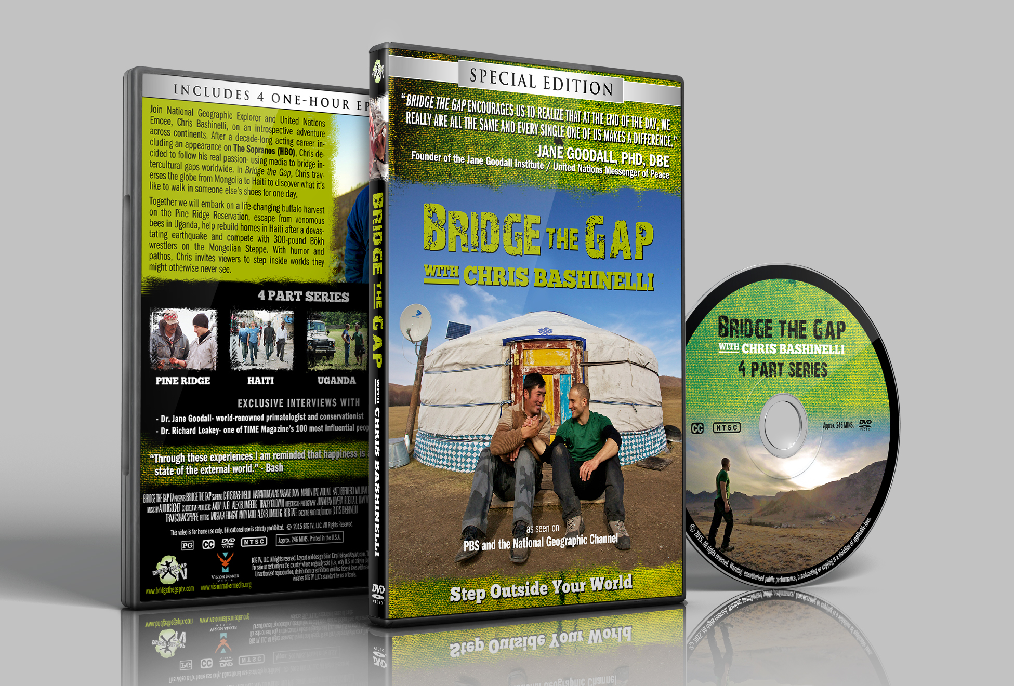
WANT TO MEET BASH?: Bash loves connecting with attendees. We have found it to be truly meaningful if participants have a chance to connect with Bash one on one at a DVD signing. By offering a signed DVD of Bash’s TV Show, featured on PBS and the National Geographic Channel, we enable the journey to continue. Here are your DVD Options.
BRIDGE THE GAP- THE ENTIRE 4 PART SERIES
As Seen on PBS and the National Geographic Channel
4 X 1-Hour Episodes plus Bonus Material
In this revolutionary new series Bash takes viewers on a trek across continents- discovering what it’s like to walk in someone else’s shoes. This DVD includes four episodes- Mongolia, Haiti, Uganda, and the Pine Ridge Indian Reservation. Wrestle with nomads on the frozen tundra, escape from venomous bees in Uganda, walk for clean water in Haiti, and embark on a life-changing buffalo harvest- all in an attempt to better understand life from another person’s shoes.
BRIDGE THE GAP TO PINE RIDGE- PREMIERE EPISODE
1 x 1-Hour Episode plus Bonus Material
This program highlights Bash’s unforgettable journey to the Pine Ridge Indian Reservation in South Dakota. While there, he embarks on a life-changing buffalo harvest, gets “schooled” by the women’s college basketball team, and finds himself shoulder deep up a cow’s backside while trying to better understand employment issues on the reservation. With humor and pathos, he uncovers stories of hope and learns how culture has prevailed in the face of adversity.
HOW TO PURCHASE? DVD’s can be sold at the back of the room after each event. An even more powerful option is for your organization to purchase DVD’s at a discount price in advance of the show. People will love a keepsake, a reminder of the event they’ve experienced. Please contact us directly for pricing.
QUESTIONS & PRICING: Please contact CMI Speakers at 877 307 7403 or Office@CMISpeakers.com

